

**Ring us during session** [**ehps1@live.co.uk**](mailto:ehps1@live.co.uk)  **07732 951613**

East Hanningfield Pre-School

**www.easthanningfieldpreschool.com**

**Newsletter**

April 2024

Hello!

A big welcome back to all the children and parents. We hope you Had a lovely Easter break.

What we are up to this term…

Our theme is **‘Water.’** We are discussing all the different types of waters. Sea, Lakes, Puddles, Glass, Ocean, Pond, Spring, River, Falls, Bowl, Canals, Streams, Fountains, Baths. We have been making crafts with the children, to relate to all the different Waters, while discussing which water creatures live in certain waters. Every week we concentrate on a different number, letter, and shape.

A sticker is awarded to every child who brings in any item starting with the letter of the week or related to the topic or shape. Please place in the basket on arrival.

**April May June**

**15th - 5 Y Star 6th - 8 B Triangle 3rd – 0,1 E Diamond**

**22nd – 6 Z Heart 13th – 9 C Circle 10th – 2, F Oval**

**29th - 7 A Rectangle 20th – 10 D Square 17th – 3, G Hexagon**

**27th – Half Term 24th – 4, H Star**

We are spending a lot of time outside if possible, so please ensure your child has a named coat with them and suitable footwear. Boots are not allowed in the hall. Only plimsolls or soft-soled shoes are permitted in the hall.

Dates for your diary…

**27th May - 3rd June** Half term

**10th June -** Fathers Day shop opens

**16th June -** Fathers Day

**8th July -** Sports Day, Lunch & Leavers

**15th July -** Last week of Term

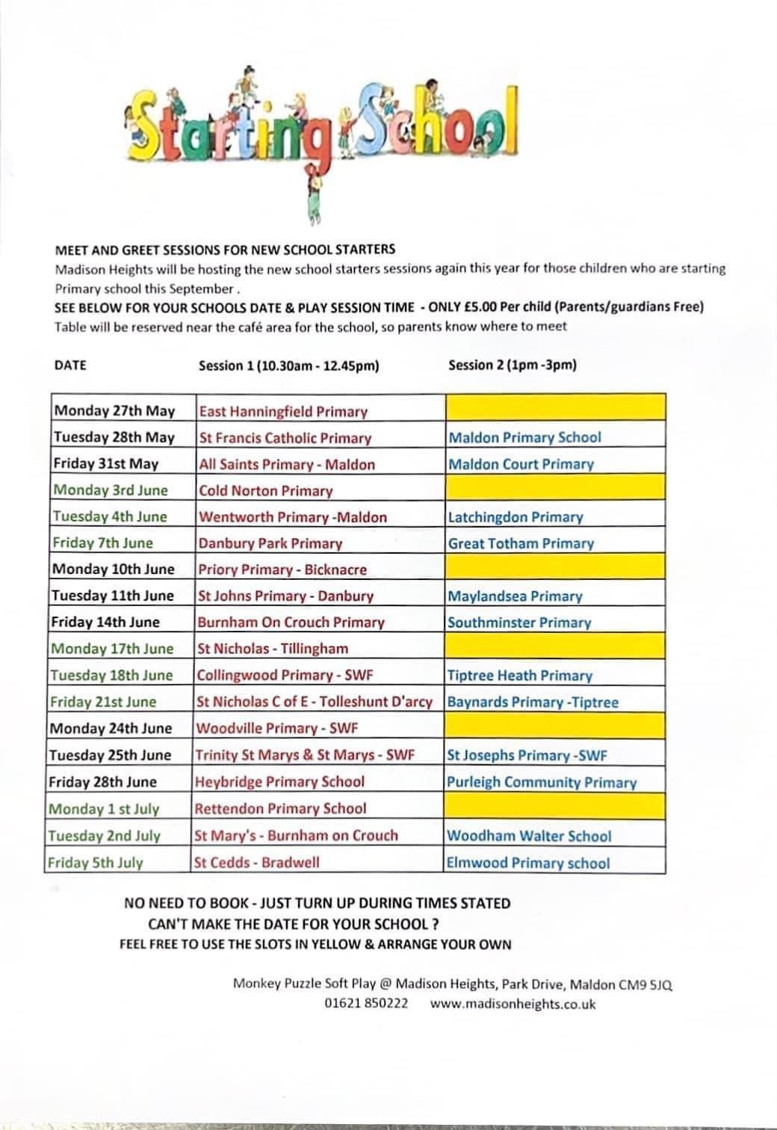

**#Funding**

Just a note on funding, parents that are eligible to claim 30 hours funding please make sure you apply for your code before the 31st march so you can claim for the 30 hours next term.

Also from April 2024 eligible working parents will be able to claim 15 hours childcare support once there child turns 2 years old. Please visit [www.childcarechoices.gov.uk](http://www.childcarechoices.gov.uk) to apply before march 31st 2024. Unfortunately, we cannot apply on behalf of parents, you will need to apply and access a code to provide to us when we hand out funding forms.

**Food Hygiene**

We would like to share the great news; we received a continued food Hygiene Rating of 5 on a latest inspection we had this week from the food standards Agency**.**

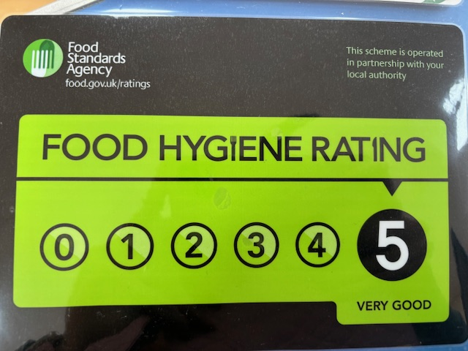

**Speech & Language support**

Communication Stations continue to run across mid-Essex for children aged 2 up to the end of reception year with a Mid-Essex GP (or if they are attending a Mid-Essex school).

These are bookable in two ways:

1. Parents calling up on the morning of the clinic to book a same-day appointment – please see our website for dates, locations and the number to call. [https://providechildrenandfamilyservices.co.uk/services/childrens-speech-language-therapy/](https://emea01.safelinks.protection.outlook.com/?url=https%3A%2F%2Fprovidechildrenandfamilyservices.co.uk%2Fservices%2Fchildrens-speech-language-therapy%2F&data=05%7C02%7C%7Cdc72659c464147aa9e7808dc6479041e%7C84df9e7fe9f640afb435aaaaaaaaaaaa%7C1%7C0%7C638495718154725556%7CUnknown%7CTWFpbGZsb3d8eyJWIjoiMC4wLjAwMDAiLCJQIjoiV2luMzIiLCJBTiI6Ik1haWwiLCJXVCI6Mn0%3D%7C0%7C%7C%7C&sdata=p%2BBi18WTVqz9ysFv8JhRSR9AXQpcwuBFYosAmBgb15U%3D&reserved=0)  please note – you do not need to complete a referral form for this.
2. Parents or other professionals can complete a referral form for a pre-bookable appointment. The form for this is available on our website (just above the Communication Station dates and locations information). This was previously just for children where there were safeguarding concerns or a need for a translator but can now be for any child. Please note there is an up to 18 week wait for a pre-booked appointment.

**Committee**

Please see below our committee members below: Please feel free to speak to anyone on the committee regarding preschool any time.

Rebecca Houghton – Chairperson

Leigh Hasan – Secretary

Ana Horta – Treasurer

Trustees

Diane Batt

Kerry Pleasant

Jodie Hempel

Sam Morris

Tom Allen

Lynne Philips

We always are open to new members joining our committee to help with fundraising and other preschool matters. If you are interested in joining our committee, please speak to a member of staff.

**Fundraising**

We have had some wonderful ideas for fundraising. Could we ask all parents and carers to sign up to Easy Fundraising, every time you shop you can raise vital funds for our preschool, all you have to do is sign up, once registered any purchases made through the app or website, the companies will donate to the preschool

Please find Link below: or alternatively download the app on your smart phone.

[East Hanningfield Pre School - Chelmsford Fundraising | Easy fundraising](https://www.easyfundraising.org.uk/causes/ehpresch/?searchSessionId=d52f3e20-cfe4-4bc9-a1ed-a05af3838486)

We are also selling numbers: £1 each per number, each number sold will be put into a pot to be picked out at random, the winning number will receive half the money raised, the rest will go to preschool.

**Facebook**

Do not forget we now have a Facebook page for passing on information so if you would like to join this please request to join as it is a closed group. It is being updated by a member of staff and a committee member.

We now also have a page set up for the public so please take a look. Reviews are welcome if you would like.

Reminders

Please let us know if your child cannot come in for their usual session due to illness, holiday, or any other reason. We will ring you to check if we have an unexplained absence.

Please continue to send in photos about what your child does or has been doing at home.

[](https://www.bing.com/images/search?q=coughs+and+sneezes+poster&id=0A4CEC23A9975CC907E8208FF37B67C7ACB46924&FORM=IQFRBA)

We have been teaching the children about good hygiene when they sneeze and not coughing over others to help reduce the spread of illness.

Other useful info…

**Changing or adding hours**

If you wish to change your hours, please let us know as spaces are filling up quickly. Please email us the changes even if you speak to us, and ensure you get a confirmation email from us.

If your child attends a child-minder or another setting, please let us know.

**Lunchboxes**

We are a nut-free pre-school so **no nuts** please in lunch boxes. This includes **pesto**. Please also check **cereal bars** to ensure nut-free. Please ensure your child has a drink in their lunchbox and no screw tops as these get knocked over. Please fill water bottles with water or diluted “no added sugar” squash. All chocolate and sweets are discouraged in lunchboxes.

If you put **grapes** in your child’s lunchbox, please ensure they are **cut in half lengthwise** so they can more easily pass-through smaller throats.

Please ensure you check your child’s lunchbox to see how much he/she has eaten for lunch. We cannot force your child to eat their lunch – we can only encourage. Uneaten food will be left in their lunchbox.

**We promote healthy eating! If you would like further information, please see our website.**

**Medication**

If your child requires any medication whilst at Preschool, please make sure you have filled out and signed the form “Parental Agreement for Setting to administer medicine.”

**Clothing**

Please do not send your child into pre-school in their best clothes as your child may get messy with paint & glue. Sometimes it is necessary for your child to have a change of clothes during the day. We do keep spare clothes but if you do borrow our clothes, please can you ensure they are returned to us.

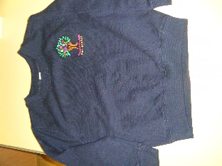

We have pre-school t-shirts for sale for £8 and sweatshirts for £11. These are embroidered with the pre-school logo. Please let us know if you would like one.

**Exclusion procedure for illness and contagious diseases**

In order to ensure that germs are not spread to others please visit our website page and do not send your child in to pre-school until after the exclusion period. If you have any doubts about whether your child is well enough to come into pre-school, please ring us before bringing them in.

**Pre-School Bag**

Please to bring your child’s personalised bag to each session so staff can fill it up with artworks, notices etc. ready for you to take home again.

**Nappies**

Can we please remind parents to provide nappies and wet wipes in their child’s bag.

**Staff contact**

If you would like to speak a member of staff, please either ring us or wait until all the children have entered pre-school. If your child comes into pre-school with a mark caused by an accident at home, please can you fill out a slip and sign it as we must record all of these.

**Wow Moments**

We love sharing these special moments with your child and we then place the Wow sheet in their Learning Journey. Wow sheets are available in pre-school and they can also be downloaded via our website.

[**www.easthanningfieldpreschool.com**](http://www.easthanningfieldpreschool.com)

**Policies**  
All of our policies are available to read on our website.

**Early Learning Journey folders**

These are updated once every half-term with observations, a photo, and artworks. You are welcome to come in and view your child’s at any time.

**Change in contact details**

If you change your mobile or home telephone number,please remember to let us know so that we can update our records. This is important in case we need to contact you during a session.